AI Project Kick-off Document

AI Project Model — PM Workflow Framework
Framework: AI Project Model (Google PAIR-Aligned)
Authors: Jason Garcia, Sarah Mitchell, Ryan Torres
Status: Draft
Date: Feb 25, 2026

Problem Statement
AI Justification
AI vs. Rule-Based Decision
Automation vs. Augmentation
Success Metrics
Technical Metrics
Human-Centered Metrics
Business Metrics
Roles and Responsibilities
Responsible AI - Initial Risk Assessment
Risks and Mitigations
High-Level Timeline
Phase 1 Gate Criteria
Approvals

Problem Statement
PMs and engineers building AI products today rely on generic project management frameworks that were not designed for the unique demands of AI development. Critical concerns such as data provenance, bias auditing, explainability design, and responsible AI checkpoints are either bolted on as afterthoughts or missed entirely. Teams create planning documents from scratch each cycle, spending over 40% of their planning time on boilerplate while producing artifacts that are inconsistent in quality and disconnected from one another — roles are re-entered, success metrics redefined, and risks duplicated across documents. This project delivers a PAIR-aligned framework where a PM populates a single structured YAML file and Claude Code skills generate the complete artifact set — kick-off document, requirements definition, milestone tracker, and review decks — with data flowing automatically between artifacts and phase gates enforcing responsible AI practices at every transition.

AI Justification

AI vs. Rule-Based Decision
Could this be solved with deterministic rules or heuristics?
No — Template population (find-and-replace) is rule-based, but several workflow steps require AI: generating cohesive problem statement paragraphs from structured context, adapting content framing for different audiences (engineering vs. leadership), and validating artifact completeness against the PAIR framework.
Why is AI warranted?
Natural language generation for problem statements and narrative sections, context-aware content adaptation across artifact types, and intelligent validation of framework compliance exceed what static templates can deliver.

Automation vs. Augmentation
Approach:
Hybrid
Rationale:
Structural population (placeholder replacement, table insertion, chart generation) is fully automated. Content generation (problem statements, risk narratives) is AI-augmented with PM review before insertion. PMs retain full control over YAML input and can override any generated content.

Success Metrics
Define each metric using the threshold-action pattern: what you measure, the threshold that triggers concern, and the action you will take if breached. Use the tables below to capture metrics across three dimensions.

Technical Metrics

Metric ID | Metric | Target Threshold | Action if Breached
T1 | Placeholder replacement accuracy | 100% (zero missed placeholders per artifact) | Audit placeholder mapping; fix YAML schema or template mismatches
T2 | Skill execution success rate | >= 95% across all artifacts | Review error logs; add retry logic or improve API error handling

Human-Centered Metrics

Metric ID | Metric | Target Threshold | Action if Breached
H1 | Time to generate full artifact set vs. manual creation | >= 75% reduction | Profile bottlenecks in skill workflow; optimize API call batching
H2 | PM satisfaction score (usability survey) | >= 4.0 / 5.0 | Conduct PM interviews; simplify YAML schema or add guided input mode

Business Metrics

Metric ID | Metric | Target Threshold | Action if Breached
B1 | Artifact consistency (cross-artifact data match rate) | >= 98% (roles, metrics, timeline match across all docs) | Audit shared YAML data flow; fix cross-artifact population logic
B2 | Framework adoption (projects using full artifact set) | >= 3 projects in first quarter post-launch | Gather user feedback; reduce onboarding friction; add project-init wizard

Roles and Responsibilities
Role | Name | Responsibility | Phase Coverage
PM (Accountable) | Jason Garcia | Overall project delivery, stakeholder alignment | All phases
Tech Lead | Sarah Mitchell | Architecture, technical decisions, feasibility | Ph. 2-5
Data Engineer | Ryan Torres | Data pipelines, data quality, Data Cards | Ph. 2-5
ML Engineer | Kevin Nakamura | Model development, training, evaluation | Ph. 4-5
UX / Product | Diana Lee | User research, interaction design, trust UX | Ph. 1, 3, 5
RAI Reviewer | TBD | Responsible AI review at each phase gate | Ph. 1-6
Eng Lead | Marcus Wright | Executive sponsor, go/no-go authority | Ph. 1, 5-6

Responsible AI - Initial Risk Assessment
Per PAIR Phase 1 RAI checkpoint: Is AI warranted? Who could be harmed? What data will be used?

Who could be harmed?
- PMs who rely on AI-generated problem statements or risk narratives without sufficient review — inaccurate framing could misalign teams
- Stakeholders who receive leadership decks with AI-generated summaries that oversimplify or misrepresent project status
- Teams working on non-standard AI projects where a one-size-fits-all framework may not capture unique requirements

Bias risks
- Framework design reflects PAIR Guidebook conventions which are optimized for consumer-facing AI products — may underserve infrastructure, research, or internal-tool AI projects
- AI-generated problem statements may adopt a solution-oriented framing bias, understating problem complexity

Privacy / PII
- YAML files may contain personnel names, email addresses, and project details
- Google Doc/Sheets/Slides artifacts are stored in the user's Google Workspace — access governed by their org policies
- No project data is sent to external services beyond Google APIs and Claude Code

Fairness
- Framework templates will be tested across multiple project types (consumer AI, internal tooling, data infrastructure) to ensure broad applicability
- YAML schema will support optional sections so teams can skip irrelevant fields without penalty

Transparency
- All AI-generated content (problem statements, narratives) is clearly labeled in the skill workflow — PM reviews before insertion
- Claude Code skills are open-source and inspectable in the project repo

Risks and Mitigations
Risk ID | Description | Likelihood | Impact | Mitigation | Owner
R-001 | Google Docs/Sheets/Slides API breaking changes or rate limits disrupt artifact generation | L | H | Pin API versions; implement retry with backoff; maintain offline YAML as source of truth | Sarah Mitchell
R-002 | Template formatting degradation from API-based text insertion and table manipulation | M | M | Use copy-and-replace pattern (never generate from scratch); test formatting after each batch update | Diana Lee
R-003 | Shared YAML schema becomes too complex as artifacts are added, reducing PM usability | M | H | Design YAML with sensible defaults and optional sections; add validation with clear error messages; consider guided input mode post-MVP | Jason Garcia
R-004 | Scope creep into portfolio management or external tool integrations before MVP is complete | H | M | Enforce MVP scope (single project, Google Workspace only); track scope requests in decision log for v2 consideration | Jason Garcia

High-Level Timeline
Phase | Description | Target Start | Target End | Gate Owner
Phase 1 | Discovery and Problem Framing | 2026-02-10 | 2026-02-28 | PM
Phase 2 | Data and Feasibility | 2026-03-02 | 2026-03-20 | Tech Lead
Phase 3 | Design and Architecture | 2026-03-23 | 2026-04-17 | Tech Lead
Phase 4 | Build and Iteration | 2026-04-20 | 2026-06-26 | PM
Phase 5 | Evaluation and Validation | 2026-06-29 | 2026-07-17 | Eng Lead
Phase 6 | Launch and Post-Launch | 2026-07-20 | 2026-08-14 | PM

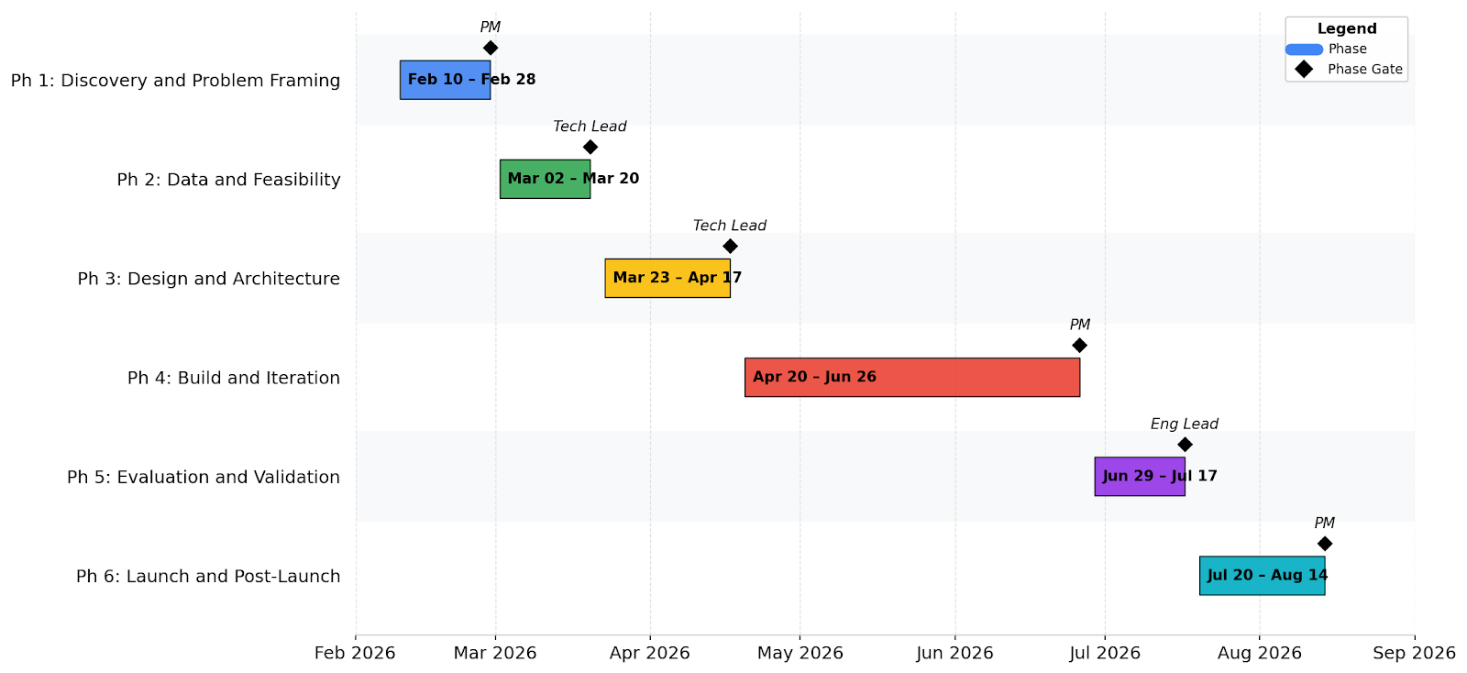AI Project Model — PM Workflow Framework — High-Level Timeline

Phase 1 Gate Criteria
This project advances to Phase 2 when all items below are checked off.

- Problem statement approved
- AI applicability justified (Section 2 complete)
- Success metrics defined with measurable thresholds (Section 3 complete)
- Responsible AI checklist completed (Section 5 complete)
- Roles and responsibilities confirmed (Section 4 complete)
- Engineering Lead / Sponsor sign-off obtained

Approvals
Role | Name | Date | Approval | Notes
PM | Jason Garcia | Date
Tech Lead | Sarah Mitchell | Date
Eng Lead | Marcus Wright | Date

